2022 JOURNAL OF LITERACY INNOVATION

ARTICLE OF THE YEAR

Youth-Led Research for Social Action: A Community Collaborates

Mary Frances (Molly) Buckley-Marudas

College of Education & Human Services, Cleveland State University

Charles Ellenbogen

Campus International High School, Cleveland OH

Rachel Oscar

Campus District, Cleveland OH

Abstract
This article offers a school-based Youth Participatory Action Research (YPAR) project as a case study for examining community engagement in the field of literacy. This telling case reflects the shared commitments of a school, a university, and a community organization to partner with the community through a participatory action research project. Drawing on the authors’ individual and collective experiences with this project, we share what we learned about literacy in and through this community engagement. The authors found that community-engaged and community-focused projects like the one presented in this article create a dynamic platform for enhancing and developing participants’ literacies. The authors share three of the key characteristics—collaborative, real, and messy—of the literacies that surfaced in this work.
Keywords: Youth Participatory Action Research, community engagement, literacy, civic engagement, school-university partnership
Youth-Led Research for Social Action: A Community Collaborates
It started, as many things do in this era, with social media. I saw a request for someone to lead a book club at the Norma Herr Women’s Shelter in Cleveland. I was curious. This shelter was close to the new high school where I would be a founding teacher, and across the street from the newly redesigned K-8 campus of our school. When I start at a new school, I look to learn about the school community and, as an English teacher, a book club seemed like the perfect opportunity. I was also learning about Youth Participatory Action Research (YPAR) from Molly, our new school’s professor-in-residence. Although I was excited about the potential of YPAR for high school students and it resonated with my pedagogical beliefs, I didn’t have a firm grasp of it at this point. —Charles, Campus International High School
It was the summer of 2017, and I just started as professor-in-residence at Campus International High School, a partner school with my university. Given my interest in action research and youth civic engagement, I proposed a YPAR project for incoming 9th graders. Although I didn’t have extensive experience designing school based YPAR or facilitating YPAR with 100 adolescents at a time, I had support from the administration and enthusiasm from the teachers. I was not sure how this project would unfold or how the community at large would respond, but when Charles contacted me, curious to see if there was a YPAR connection with this local organization and women’s shelter, I was reassured about the potential of this work. --Molly, Cleveland State University
In 2017, Campus District was interested in the highly trafficked area of Payne Avenue. Cleveland State University students traverse it to get to their classes, apartments and athletic fields, hundreds of shelter residents travel the street every day, and hundreds of children from the new PK-8 school on the street walk the street as well. Despite this, the urban landscape left a lot to be desired. At the time, there were no places for people to comfortably sit and there was little that felt welcoming about the street. At Campus District, we saw these challenges as opportunities for members of our community to create place, meet new people, and bring some vibrancy to the area. We imagined a project where neighbors would come together to plan, design, and implement ways to use cultivate a sense of vibrancy along Payne Avenue. This process aimed to build meaningful connections between members of our community and the result will add a sense of identity, an element of comfort, and fun to the neighborhood. --Rachel, Campus District
Engaging the Community through Youth Participatory Action Research
As our local and global communities continue to face deep-rooted and pervasive social inequities and injustices, we, an Associate Professor of Adolescent & Young Adult English Education (Molly), a teacher of high school Language & Literature (Charles), and the Director of Programming and Community Engagement for a community organization (Rachel), approached this work with the belief that educators and community leaders have a responsibility to support young people as they develop their capacity for community and civic engagement and create pathways to confront pressing social issues. In response to far too many incidents related to police brutality, gun violence, deportation, climate change, COVID-19 and more, we have witnessed the power of youth civic participation and the potential of young people’s voices to initiate social action. We are committed to making school a place that deliberately fosters student agency around issues in their communities. We believe that this work is most impactful when it takes place in the context of students’ local contexts and in collaboration with community stakeholders. In keeping with the theme of this special issue, this article offers a school based YPAR project as a case study for community engagement. This case reflects the shared commitments of a high school, a university, and a community organization who partnered with the community through a participatory action research project. Drawing on our individual and collective experiences with this project, we will share what we learned about literacy in and through this community engagement.
In the fall of 2017, two of us (Molly & Charles) were part of a school team at Campus International High School (CIHS) that allowed us to put our hopes for youth community engagement into practice. This school team designed and implemented a collection of learning opportunities during the school day that aimed to support youth to raise their voices for social action and change. Drawing on our own pedagogical beliefs and YPAR traditions, this project recognized the significance of working with youth and honoring them as knowledge generators. We engaged in this work with the belief that YPAR is a compelling way to support youth agency. In this article we share what happened with the project we hinted at in the opening vignettes to illustrate the potential of YPAR to serve as a vehicle for youth activism and community engagement. This project, referred to as the “Payne Avenue Project”, was one of 24 total YPAR projects conducted by 9th graders at CIHS in 2017-2018. The Payne Avenue Project surfaced as a telling case (Mitchell, 1981) of YPAR-in-action because it reflected the kind of active learning and engagement that is possible when young people, teachers, community members, and university researchers commit to community-based, action-oriented work in real-time.
Background and Conceptual Framework
Given our intent to expand youth civic participation in meaningful ways and connect students with their community, we saw YPAR as one way to develop student agency. Given our long-term goal of situating young people as researchers and knowledge generators, our school also saw this YPAR project as year one of what we envisioned as a 4-year progression of research courses. Although there is a growing body of research on YPAR in school settings (Cammarata, 2016; Ozer & Wright 2012; Rubin, Ayala, & Zaal, 2017; Voight & Velez, 2018), we hoped that this work would extend existing frameworks for YPAR in the context of the everyday curriculum for students in urban, public schools.
Consistent with YPAR traditions, the project at the center of this article was grounded in the belief that young people have the capacity to generate knowledge that can generate social change (Cammarata & Fine, 2008; Duncan-Andrade & Morrell, 2008; Mirra et al., 2016). YPAR is grounded in the idea that youth are capable of conducting research and creating new knowledge. YPAR positions young people as deliberate and agentive members of the community. YPAR pedagogies aim to position students as co-researchers and center the perspectives of young people (Irizarry & Brown, 2014) as they examine pressing community issues and discover possible outcomes for improvement (Ozer, Newlan, Douglas & Hubbard, 2013).
Youth-led research in young people’s local communities allows them to direct their own learning There is a growing body of the research that documents the ways in which YPAR fosters youth civic engagement, student voice, and research skills (Ozer & Wright, 2012). This work has been documented to increase youth’s social, emotional, and cognitive outcomes, foster critical thinking and academic success, and encourage civic participation (Voight & Velez, 2018; Diemer, Voight, & Mark, 2011). Although the growing body of research is helpful for understanding the value of YPAR and for developing YPAR projects, it does not always tend to the nuances of enacting this work within the institutional context of school.
Drawing on our understandings of YPAR and our knowledge of the long-standing requirement of the high school “research paper,” we saw youth-led action research as an alternative to high school research as we typically know it. For the two of us working in the high school, YPAR, as a method and a framework, could refresh the time-honored high school research project and paper (Buckley-Marudas & Ellenbogen, 2017). Typically, the high school research paper requires students to demonstrate their research and writing skills. The most common outcome is a written paper that is submitted to the teacher. We were interested in expanding the ways in which the research could be conducted and the range of formats for the final outcomes. Central elements of YPAR, whether in-school or out-of-school, are research and action. As a result, we hoped to see fewer students focus on some of the typical topics (e.g., medical marijuana, the death penalty, using animals for product testing) for YPAR projects. Given the explicit focus on engaging all steps of the action research cycle, we hoped that we would avoid the common framing of research as a kind of “reporting back” on students’ reading and review of existing literature and previously published reports.
This project was also grounded in a commitment to the democratization of the urban planning process and conceptualizations of space and place. Specifically, our work was informed by the concept of “creative placemaking” (Markusen & Gadwa, 2010). Place has a unique capacity to bring people together, yet it also has a unique capacity to divide people. A challenge to improving community engagement is creating a sense of belonging within a space, both in terms of the physical characteristics as well as the kinds of habitual practices and routines that are associated with or provided by a space. Creative placemaking is a process that brings together a range and variation of community members and stakeholders to strategically and thoughtfully redesign a neighborhood, street or other physical space. According to Markusen and Gadwa (2010), “Creative placemaking animates public and private spaces, rejuvenates structures and streetscapes, improves local business viability and public safety, and brings diverse people together to celebrate, inspire, and be inspired.” For Campus District, a core principle of the Payne Avenue Project was the democratization of the urban planning process. We hoped that by helping students understand how our built environment is created, we could embolden them to have a say in creating inclusive places that reflect their ideas. A key to this was learning the language of cities—what is the story of a vacant building? A broken sidewalk? A street with no trees? Conversely, what is the story of a public mural? A well-lit roadway? A park bench? Learning and reflecting on the language of cities and the stories that existing built environments tell about cities would be part of this project.
This project was guided by several questions. We wondered: 1. What happens when adolescents are asked to conduct research for action in their communities? 2. What literacies are developed and/or expanded in the process? 3. What are the limitations and possibilities of YPAR in school?
Method
The Research Context
This inquiry took place in multiple physical contexts, including the high school and local community centers and was built around an existing school curriculum based on Youth Participatory Action Research.
School Context: Campus International High School
Campus International High School, a public, open admission high school in Cleveland, opened its doors in the fall of 2017 to a class of 100 9th graders. CIHS was designed as an International Baccalaureate (IB) school. A key component of all IB schools is an action-oriented project, referred to as the Community Project. Motivated by a growing body of research that documents the value of Youth Participatory Action Research for fostering youth civic engagement, research skill development, and voice (Cammarata & Fine, 2008; Duncan-Andrade & Morrell, 2008; Mirra, Garcia, Morrell, 2016; Ozer & Wright 2012), Molly proposed the idea of a school-based YPAR project to the incoming CIHS principal in May 2017. Molly proposed the project to extend youth action beyond the required Community Project and as a way to build a strong culture of research in the new school. The principal offered a resounding “yes.”
The Community Context: Campus District & Payne Avenue
A core principle of the Payne Avenue Project for Campus District was the democratization of the urban planning process. Thus, a goal of this project for both Campus District and CIHS was to engage young people in thinking about the built environments that we use and that surround us and to create room for them to contribute to the development of the existing built environment on Payne Avenue. Of course, the stories of the built environment are only one part of the language of cities. The other part is the stories of the people. From an organizational perspective we had a K-8th grade school, serving over 700 students daily, sitting across the street from the largest women’s homeless shelter in Ohio, serving 250 women daily. A center of education and a center of healing, separated by Payne Avenue. From an urban planning lens, youth and individuals experiencing homelessness share similar traits—transient populations whose voices are often overlooked when it comes to designing and creating spaces they utilize. We felt that not only could they learn a lot from one another but that by simply creating the occasion to meet and talk, we could reinforce the humanity and value of each person’s opinions. And this learning—uncovering how we are more similar than we are different—was crucial to the success of the project. The idea to conclude the first major phase of this project with film production and video editing felt like icing on the cake—a way to create multiple entry points for students interested in the project and expand their storytelling toolkit. In addition to the excitement and satisfaction that came with producing and editing the film, storying this space forced us to engage in yet another “reading” of Payne Avenue.
The Curricular Context: School-based YPAR
In the summer of 2017, Molly developed a basic framework and overarching timeline for what the YPAR curriculum would look like at CIHS. Building on her existing commitments to critical literacy, critical inquiry, and adolescent literacies, Molly aimed to design a curriculum that was structured enough for teachers and students who were new to this research tradition, yet flexible enough to accommodate the range of topics students would identity and the various possible actions that would surface from students’ research. Molly borrowed heavily from the resources developed and shared online by the YPAR Hub at University of California Berkeley (http://yparhub.berkeley.edu/).
Working in small groups of two to five students, 9th graders would conduct original research to address a specific community issue that they identified as important. To be successful, students needed to complete all steps of the action research process from developing research questions to collecting and analyzing original data and presenting research findings to taking steps to address their issue. Given the explicit focus on community issues, this work would naturally include some investigation of power, class, and/or bias.
During the first quarter of the school year, students developed research questions to address an issue they identified. By the end of the first quarter, students started to conduct research on the questions they had developed. Several groups pursued questions about bullying and school lunch. Other groups pursued questions related to violence, stress factors for teens, teens’ understandings of suicide, and the relationships between teaching styles and interest in school. The group at the center of this article began with the question, “How does homelessness affect children in Cleveland?” They had a specific interest in understanding the experiences of displaced youth who are in high school. As a community, all members or the school community were responsible for thinking about connections that might open avenues for action for students. When learning of this group’s interest, Charles connected this group to Rachel. Like many YPAR projects, the group’s focus and research question evolved as they became more closely connected to community members and stakeholders, as well as the nuances of the immediate community issue. During the month of February, Campus District and CIHS students worked together with shelter residents to talk about design principles and improvements that could be made on Payne Avenue. The final product of this phase would be a fundraising video about what they learned to raise funds for the desired changes. A local Cleveland film company, Purple Films (https://www.purple-films.com/), agreed to support students, Campus District, and the school to produce the final video. Five distinct meetings with youth and different stakeholders took place. We will draw on some of the interactions, experiences, and learnings from the meetings in the following sections. Briefly, the meetings stretched from late January through March and took place at various locations including the high school campus, lower school campus, and a local community center.
Results
Exploring the Literacies of Community Engagement through YPAR
As we reflected on our experiences in implementing school-based YPAR, generally, and the Payne Avenue Project, specifically, several ideas emerged that helped us characterize the literacies that were required and/or developed during this community-engaged work. What we found deepened our understandings of literacy as it relates to meaningful and impactful community engagement and illuminated the ways in which different kinds of community partnerships and interactions with different stakeholder groups extended all participants’ evolving literacy practices. Ultimately, our work builds on the idea that community partnership work is a dynamic platform for literacy learning. Given our focus on thinking about the role and possibility of community-engaged work as part of the everyday work and curriculum in schools, this dynamic platform dramatically revised what most educators have come to see or define as “typical” high school research and the “research paper”. The literacies we found were not linear and they did not map perfectly onto a specific, pre-determined set of standards.
We came to characterize the literacies we observed as collaborative, real, and messy. As we looked back on the project, we recognized how this kind of community engagement and partnership expanded traditional notions of who facilitates literacy teaching and where literacy teaching takes place. Contrary to the idea that literacy learning is something that happens strictly in school, this case revealed literacy learning as a series of conversations, meetings, and experiences with various people. Literacy learning took place in both in-school and out-of-school spaces, and it unfolded with people of different ages, backgrounds, roles, and social positions. This collection of literacies helped us develop a clearer understanding of the potential of community engagement in the field of literacy but also a more expansive framework for our evolving school based YPAR pedagogy.
Collaborative
Although it was not necessarily surprising to find that community-engaged literacies were collaborative, this work illuminated some of the nuances of what collaborative literacies looked like in the context of this community-school-university partnership project. Furthermore, we gained new insight on was required to cultivate, support, and sustain literacies that were collaborative. One component of this collaborative element of literacy was that it was rooted in and emerged from deliberate and thoughtful connections between people and groups with some shared interest. At times this connection was tied to the Payne Avenue project, yet at other times it was tied to broader shared interests in the community.
For example, in the case of the Payne Avenue project, the collaboration started well before the actual project launched when Rachel, representing Campus District, guided Charles on a tour of the CIHS neighborhood. Campus District, a local community organization in Cleveland is described as a “connecting agent.” Later, Rachel contacted Charles and asked if some members of the school community wanted to participate in what was called a visioning project for Payne Avenue, particularly the section of this street that houses the shelter for women, where Charles volunteered, and the site of the high school’s K-8 campus. Molly and Charles learned that one of Campus District’s end goals with this project was to produce a fundraising video to raise money to support the costs associated with the future beautification of this section of the street. Charles agreed on one condition: he didn’t want our students used as cute props to help raise money, but then cast aside once the work began. Rachel agreed.
Although Molly and Charles were connected to the high school, it made sense to include students from the lower school. The K-8 building is located right on Payne Avenue and across from the shelter. We also hoped that any 8th graders involved in the project would become YPAR leaders when they arrived at the high school. Charles reached out to the lower school campus and learned that several 8th graders had shown interest in neighborhood improvement projects. Rachel connected with the women's shelter to invite interested residents to join the project. From there, a series of different meetings were arranged.
The first meeting was scheduled for late January of 2018. This meeting took place early one morning at the high school. Participants included members from the lower school, upper school, CIHS, CSU, and Campus District. This meeting was designed to talk through many of the logistical details of the project, the goals of the upcoming meetings with students and residents from the shelter, permissions that were required for the field trips and media release, and preliminary visioning for the fundraising video.
The second meeting also took place in late January 2018. This second meeting brought together high school students and teachers, lower school students and teachers, CSU professors- in-residence and Campus District. Image 1 shows the written agenda for this second meeting.
Image 1
Agenda for January 25 meeting
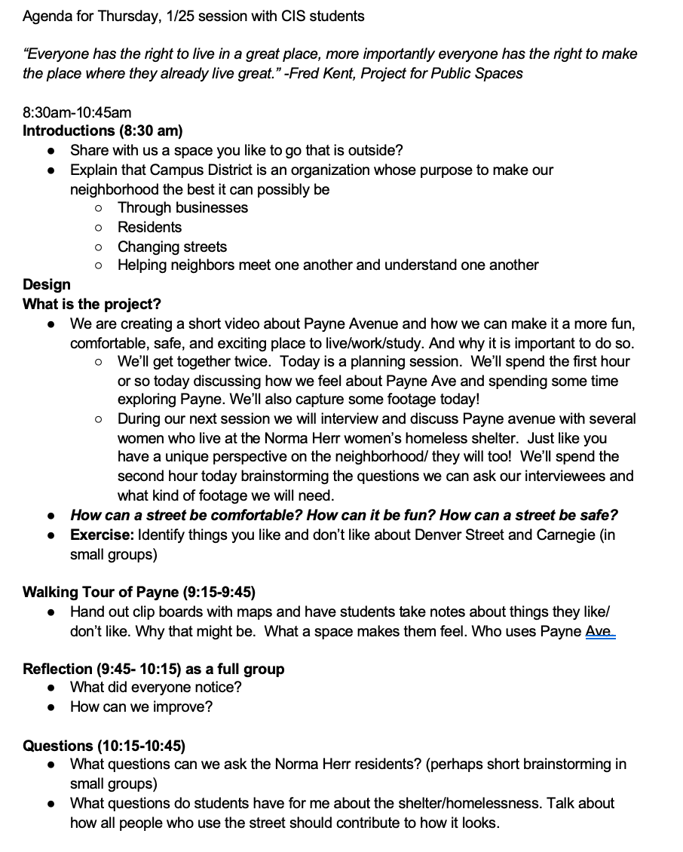
The students received training on how to use video equipment from the CSU professor-in-residence at the lower school, learned strategies for conducting focus groups and interviews, and brainstormed ideas that could serve as a core message for this project, all of which are key skills for any YPAR project. During this meeting, Rachel facilitated a series of conversations with the students and teachers that were designed to get all of us thinking about what kinds of features characterize places that we find comfortable, inviting, or welcoming. Together, we generated a long list of key elements.
During this meeting, all of us went outside to conduct field observations of Payne Avenue. In small groups, we walked up and down both sides of the street, with clipboards and pens, stopping to talk about and document what we noticed. What did we see? What activities were taking place? Who was on the street? We also took note of things we did not notice. To support students’ skill development with videography, three students practiced using the camera with a faculty member. Image 2 and Image 3 offer two pictures that were taken as students, teachers, and professors conducted field observations on Payne Avenue.
Image 2
Students, teachers, and professors explore Payne Avenue, taking notes on what they observed
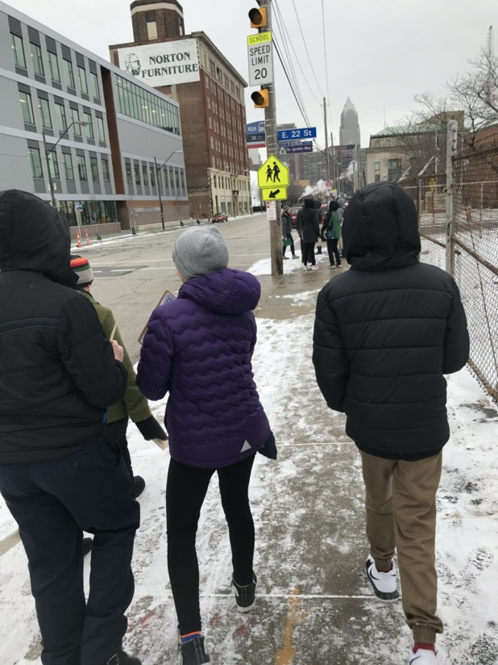
This second in-person meeting was a critical step for creating room to build a spirit of collaboration between different groups. Rachel deliberately made space during this meeting to engage all of us, students, teachers, professors-in-residence, to start learning and using the language of cities. In order to co-create a future space, we had to find ways to talk about what we did see. The field observations would allow us to share and talk about our observations and what sense we made of the physical environment. As Rachel reflected, an illustrative memory was during our second meeting when we took a walk through the neighborhood. Rachel shared:
My group stopped in front of the Norma Herr Women’s Center (the women’s shelter opposite the lower school campus) as one student noted there was a lot of trash. I prompted the students to think about why there might be a lot of trash in this area. One offered ‘maybe the women at the shelter don’t care,’ another ‘maybe people are throwing trash out of their car windows,’ and finally someone shouted—looking side to side, searching the street—‘there are no trash cans!’
Image 3
Students stop and observe the front entrance of the women’s shelter.
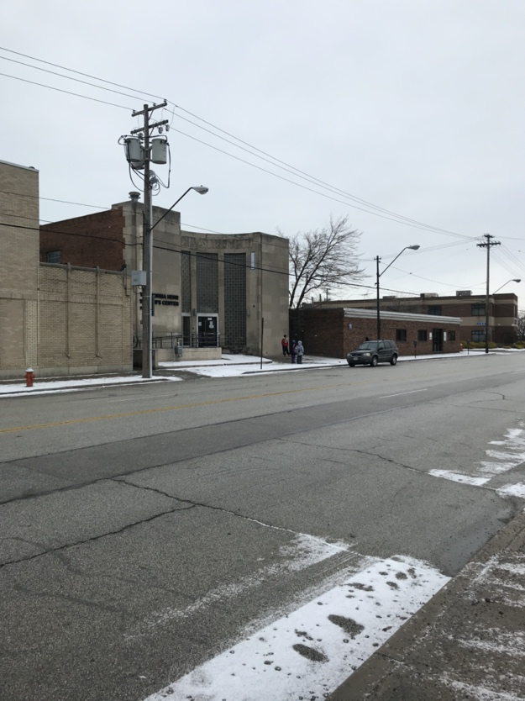
The collaborative was strengthened by Rachel's knowledge of urban planning approaches, especially her capacity to engage in asset-based urban planning and design. In and through the process of engaging, collaboratively, in assessing the physical environment, we were able to consider some new perspectives and alternative ways of seeing. This involves creating spaces where individuals with different social identities and different ways of reading the world are able to share different points of view. As illustrated in the example above, the time built in for collaborative work and sharing observations allowed the observation about the absence of any trash cans to be voiced.
After the focus group and observation experiences, we came back together as a whole group. We took turns sharing our impressions of the street and ideas for ways to improve it. As illustrated in Image 4, we collected a list of things that we might add to the built environment.
Image 4
The collaboratively generated list of ideas about what might be added to this physical environment
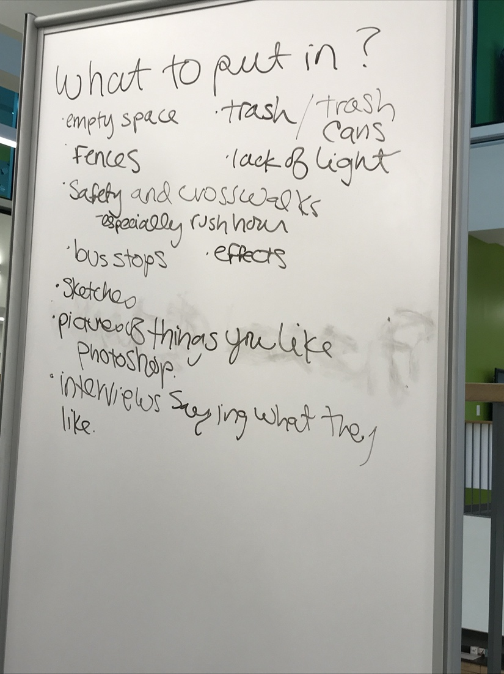
Together, we developed questions for the interviews and focus groups focused on vision and preferences for the street that would happen in the upcoming meeting with shelter guests. We also refined our project’s core focus and brainstormed what kind of material we needed to capture in order to represent this project in video format. Although the project had evolved from their initial question, the high schoolers had become more invested as a result of the ongoing collaboration and developing relationships to other Payne Avenue stakeholders. One high school student shared his excitement. “I want to hear their stories,” he said. This student, along with his peers, brought a sincere interest in understanding shelter guests’ stories. It was important to hear his interest in stories, because news media outlets often report information by the numbers, thereby removing the human stories and the lived experiences. Charles's existing relationships and connections contributed to the project because he encouraged one of the women who came to his book club to be involved. Charles’s personal invitation and connection made a potentially generic invitation much more personal. She joined the project.
Real
The literacies that surfaced in and through this kind of community-engagement could also be characterized as “real.” In contrast to the idea of “doing” research by analyzing material from the library or online sources, students gathered original data by engaging with people in the community. This work happened in real time and addressed current and immediate problems in our community. The email referenced in the opening vignette was a catalyst for this project, but it was born out of actual issues in our community that everyone in the project identified with and/or cared about in some way. In the same email exchange that is referenced in the opening vignette, Charles wrote the following to Molly:
Here's what I learned ---There are two homeless shelters in our district. (The women's shelter is right across from the new K-8 building.) It will be a challenge to do any work with them because there are sexual offenders among the residents. That said, Bobbi [then the director of Campus District] said, there are possibly some opportunities for students while the residents are out of the building, including landscaping, etc. This did raise an issue that the district is struggling with, one that could be a topic for our students: What options are there for the homeless during the day? There has been talk of a park, but it hasn't gone far. (Personal communication, July 4, 2017).
This project responded to an authentic question facing displaced residents in Cleveland: “What options are there for the homeless during the day?” Before students could answer this question, they needed to understand the existing options and they needed to talk directly with residents about desirable options. Students conducted their own observations of the street and designed interview questions for shelter residents. It was determined that if we wanted to improve Payne Avenue, we needed to meet in person. It was also determined that we needed input from all the residents on the street, especially residents who are there after the school day ends. In the process of information gathering and analysis, the research came to life: numbers and statistics were no longer disconnected or anonymous.
In response to the sense of urgency of the issues and what was understood to be a real and immediate need, this group agreed on a next meeting. This meeting took place at a neutral site. On a usual winter day in Cleveland (cold, gray, and snowy), an unusual combination of people (Norma Herr residents, CIHS students and teachers, CSU faculty, and Campus District employees) gathered at a local community center after lunch. The goal was to have a collaborative conversation about how to improve the street we shared. Image 5 illustrates the agenda that was planned for the meeting.

Image 5
Agenda for Meeting #3 at a neutral site with shelter residents, students, teachers, and professors
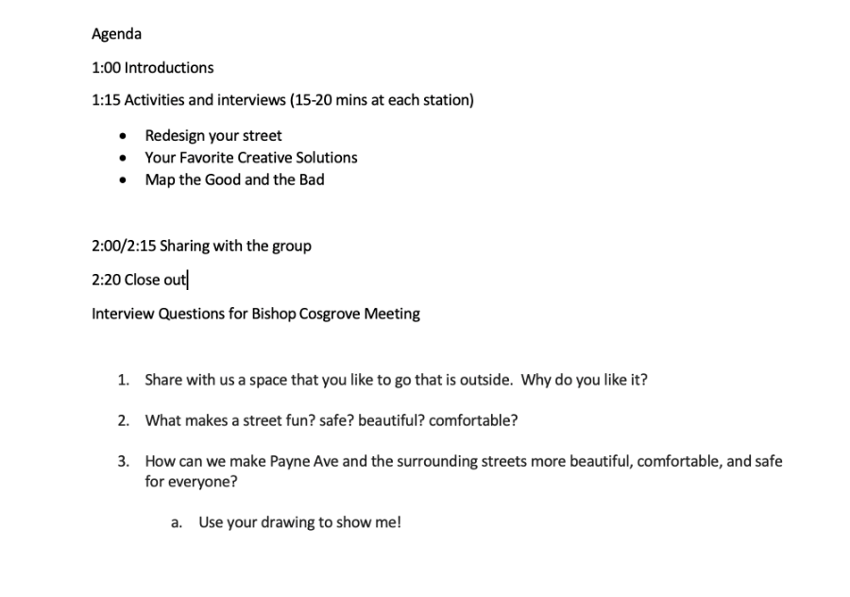
Not surprisingly, given each group’s inexperience with each other, the presence of video cameras, and a few adults in the background, things started slowly. The interviews that students led with shelter residents took place on one side of the room. Although the interviews generated some important individual ideas, more dynamic interactions happened, as they often do, in the more informal conversations at the focus group tables as the women and students arranged, discussed, rearranged, and debated ways in which Payne Avenue could be more attractive and more useful for the residents of the shelter, CIHS students, and the CSU students who all use it on a regular basis. Drawing on her urban planning experience and offering a vision of data collection for YPAR projects, Rachel brought tangible props. She had enlarged photographs of Payne Avenue as it currently stands, from different angles. She also had printed images of things like a coffee shop or a park bench that she thought people might like to see on the street to facilitate the focus group work. There were markers, crayons, scissors, and pencils available at every table to imagine and craft a new vision for the street. The students and the women had a clear task: work together to create images of their ideal or preferred street. That broke the ice.
The task not only generated substantive, in-the-moment conversations around the topic of street improvement, but also in-depth dialogue about one another’s lives. What we think about dogs and other animals, favorite school subjects, and hobbies all came up naturally during the conversation at one table. Opinions on the need for bike lanes, trees, parking lots, and street signs shed insight on participants’ perspectives on community. As seen in Image 6, “Students and shelter guests participate in a working focus group,” tables produced several visual diagrams of their ideal streets by the end of the focus group session. The once blank images of the street were now enhanced by benches, trash cans, streetlights, bike lanes, pedestrian crossing signs, trees, clearly defined parks and more. Students were engaged in the work. Whether talking in the small groups, facilitating the interviews, or managing the video cameras, we observed that students took ownership over the material and felt responsible for the results.
Image 6
Students and shelter guests participate in a working focus group
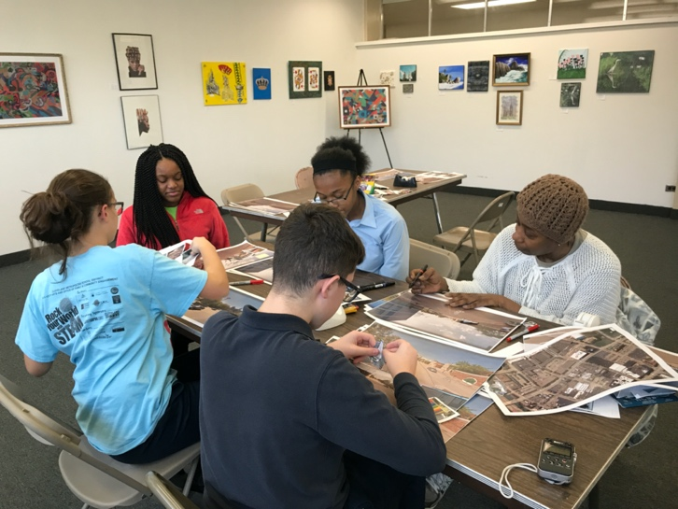
In addition to the focus groups, students conducted the formal interviews during this meeting. Drawing on the collection of semi-structured questions, two students facilitated the interviews, and two students managed the video cameras. After the interviews, the entire group gathered for a whole group conversation. During this time, some shared the most interesting ideas that had surfaced during the working focus group, and others talked about their enthusiasm for this project. One shelter resident took a few minutes to share her opinions on the topic of street improvement and beautification, some of which stood in stark contrast to the ideas that had come earlier from other residents.
After the large group meeting, there were two final meetings, one at the upper school and one at the lower school, which focused on film production and editing. The final two meetings were facilitated by a local film studio, Purple Films, in Cleveland that agreed to help produce the piece. Part of this meeting involved an introduction to film production, including a mini lesson on the stages of pre-production, production, and post-production. The primary part of this meeting was workshopping and editing what would become the published fundraising video. We talked through the message and the extent to which it was clearly communicated. We talked about layout, tone, and music and image placement. What was nearly 6 hours of tape was ultimately reduced to three minutes. Students had many opinions about the music that was used and writing a storyline that started with a more depressed tone and became lighter as the video progressed towards an improved street. The film studio shared all the raw material with us so we could practice editing film and crafting a storyline. We all quickly understood how much effort it takes to move from hours of footage to a coherent, powerful video of roughly two minutes. Students also understood how media, including the images and videos we see on social media and cable channels, narrate and create the stories that we see. They understood the power of film production and video editing in a new way as they decided what tone to set, what words to use, and what images to choose. Ultimately, a final video, filmed entirely by CIHS students, was produced and distributed in order to raise funds for this street improvement project. The video, available through this link: https://www.youtube.com/watch?v=KrsSfnE2apE was distributed on YouTube, ioby and other social media platforms.
Messy
This work was complex and messy. It was evident that the literacies required for this kind of community-engagement were flexible, responsive, and in-the-moment. Consistent with nearly any participatory action research project or grass roots community organizing, the Payne Avenue project did not proceed in a straight line. From the technical, yet essential, elements of scheduling dates when students and shelter guests could both be present and teaching students some basic skills of interviewing and videotaping to developing a shared understanding of the project’s aims and agreeing on goals, this project took a great deal of time and coordination. Dates were rescheduled and some participants missed some sessions. The group had to hear, process, and come to decisions on different ideas and hopes for the space. There was agreement and disagreement on top priorities. Learning how to navigate the non-linear nature of the research process and persevering through setbacks and rescheduled dates was a significant part of this experience. We believe that this is a literacy practice that is essential for nearly all community-engaged, civic-oriented projects.
From the organization of data and identifying research participants to analyzing results, all of us learned first-hand that there is not one way to do participatory action research. In our experience, every YPAR project—like Payne Avenue—had a trajectory all its own and students and teachers had to be willing to embrace that trajectory and find ways to support students’ projects and cultivate community connections that would be meaningful and authentic to the goals of the project. YPAR cultivated student agency related to civic engagement, but also helped to build specific skills needed to do activist work. The early work to establish a message and a shared vision for the work was critical to this community engagement in that it grounded the group as we navigated the complex, nonlinear pathway. Image 7 shows a picture of the whiteboard with the message that was generated during one of the group brainstorms about the story we hoped to tell and the goals we had for this work.

Image 7
Ideas generated during a group brainstorm about a message that would anchor the project
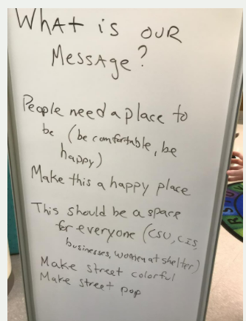
In keeping with one of the central tenets of the action research process, this work was iterative. Although most schools in the United States are not well-suited to embrace the iterative process that is common to YPAR, we housed this work in a formally scheduled class period that functioned as an interdisciplinary research class and advisory period. Although we hope that most of the activities and classes during the school day support students’ academic learning and social and emotional learning, we found it useful to facilitate YPAR during this research and advisory period because it was not tied to a specific high-stakes test or external measure of accountability. One of the great elements about this project being year 1 of a 4-year research sequence, is that students are free to continue with their topic and project in later grades if they are interested.
Consistent with the iterative nature of action research, YPAR generates new questions and new projects. As such, this project and related work was far from complete when the school year ended, and students moved to the next grade. In summer of 2018, the conversation continued. Rachel engaged in planning conversations with various community members about the vision for the improvement of the street and worked to develop a plan of priorities for using the funds raised. As Rachel shared in an email with Molly and Charles in July 2019, “The plan moving forward is for these three elements to incorporate design and artwork created by guests at the shelter and the students.” (Personal communication, July 17, 2018). By August 2018, the conversations led to a targeted list of three ways to use the funds: 1. A planter in the circular part of the area outside of the shelter. That would incorporate some seating, 2. Colorful/artistic trash cans, 3. A mural to go on the front-facing wall of the shelter and possibly a companion one on the CIS side of the street. Rachel coordinated the recruitment of shelter guests who were interested in the project, the arts, and creative expression and team members from UH would coordinate the recruitment of additional students to work on this new phase of the project. The summer 2018 sessions with shelter residents had been so popular that additional sessions were created. In September, the students and shelter residents will come together again to begin to create the artwork that will go on the planter, mural, and waste receptacles. In Image 8 we share an overview of the project plan and timeline, as outlined by Campus District.
Image 8: Project Plan and Timeline Outlined by Campus District
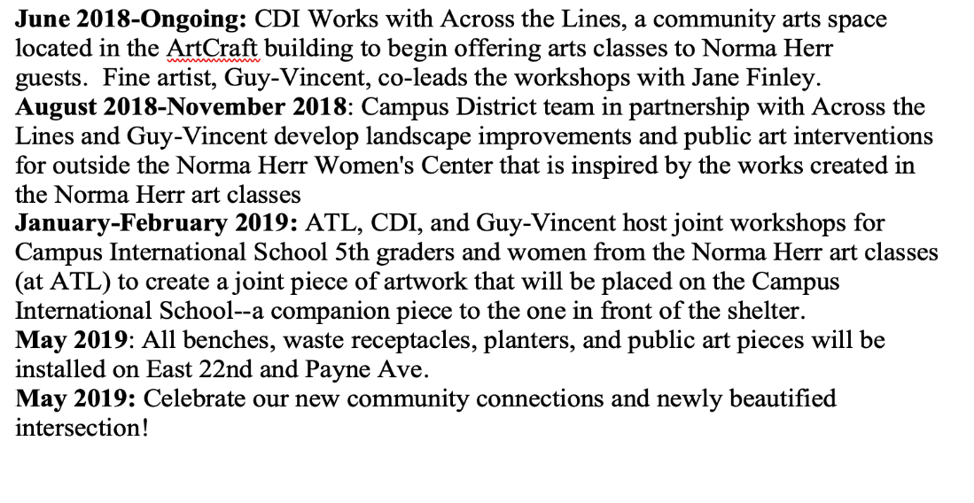
Discussion
Integrating YPAR in Other Contexts: Thoughts for Practitioners
As we shared above, this work supports the idea that there is not one “right” way to implement YPAR. A critical part of the Payne Avenue project was a commitment to the iterative and non-liner nature of the work. That said, we want to offer some advice and recommendations for practitioners who are interested in doing similar work in their classrooms, schools, and/or local communities. We think one of the most important aspects of this work is local support. Whether this support comes primarily from administrators, department colleagues, and/or community members, this work requires local support. Support is necessary for having the instructional space and agency to implement and adapt the program as you see fit. Support is also critical in the process of making community connections and building relationships that could collaborate and co-lead projects with young people.
A first technical recommendation is to think about and identify where this project could live in your classroom and/or school. Is there a specific thematic unit that aligns well with the goals or aims of YPAR? Is there an existing project or outcome, like the high school research paper or a senior capstone, which could accommodate a YPAR project? Where and when could this fit into your class or your school? In our case, we created a research class that was on all 9th grade students’ schedules. The class was approved and integrated because it was aligned with the school’s IB framework and vision. Our YPAR class was on students’ schedule for the entire academic year and was taught by teachers of different content areas.
YPAR projects, however, could be integrated as part of a content area class, an elective class, or a seminar or specialized capstone class. YPAR can be integrated with English, Social Studies, Math and/or Science content areas. There are a growing number of examples of YPAR in school. The following two articles offer examples of how YPAR can be aligned with core content classes: 1) Youth Participatory Action Research as an Approach to Sociopolitical Development and the New Academic Standards: Considerations for Educators: https://eric.ed.gov/?id=EJ1082403 and 2) Participatory Action Research: A Powerful Model for Youth Climate Literacy in PK-12 classrooms: https://tenstrands.org/place-based-learning/youth-participatory-action-research-a-powerful-model-for-youth-climate-literacy-in-pk-12-classrooms/. In addition, here is an article that offers a closer look at the overarching school-based YPAR project at CIHS from which the Payne Avenue project surfaced: https://library.ncte.org/journals/ELQ/issues/v41-2/29839.
Although a semester or a whole year allow for sustained engagement over time, YPAR projects could be conducted with as little as six weeks if when time is a constraint. Once a practitioner identifies the time available for the project, we recommend dividing the action research process, reserving a little more time for the topic identification and data analysis phases. Additional time spent on topic identification supports students in selecting a topic that is truly meaningful to them and one that is researchable, and the data analysis phase is a time intensive step in the process. For our yearlong project, the action research process was divided by academic quarters. Specifically, Quarter 1 focused on topic identification. During this phase, YPAR was introduced as a research methodology, students defined community and identified community issues. By the end of this quarter, students would have identified a topic and a research question. The 2nd quarter revolved around research methods, introducing students to field observations and surveys. By the end of this quarter, students had initiated their data collection. In the 3rd quarter, attention turned to data analysis and presentation of findings. The last quarter was dedicated to support the action step. We have learned that young people may need additional guidance with the action step. The Payne Avenue project’s action step was successful because of the number of co-leaders and community partners invested in the project. The more connections that can be made along the way will increase the likelihood for a meaningful action step. We strongly recommend a clear and simple tracking tool to help track and gauge the progress of the student groups as they make their way through all phases of the project.
We strongly recommend that anyone who adopts YPAR in their practice should create a dedicated space for youth to share their work with an interested audience. For us, we organized a research conference at CSU. At this special event, all students had the opportunity to share what they learned and what action steps they took or would take to address the issue with community members, university faculty, and more. For any practitioners interested in seeing what a culminating event could look like, we will share documentation from two of our youth-led research conferences. In addition to the specific audience for doing the work on Payne Avenue, the group was able to present their findings at this conference. The first link is to Campus Conference 2018 (https://www.clevelandmetroschools.org/Page/13199) and the second to Campus Conference 2019 (https://www.clevelandmetroschools.org/domain/5414). We suggest you visit the site to see one possible approach to showcasing youth work. We also recommend the conference sites because you can scroll through the entire list of student topics and research questions as well as visual images of our conference layout. During the conference, all youth participated as presenters and audience members and all presenters received feedback on their project from their peers and community members.
For practitioners interested in lesson plans and other resources for introducing and implementing YPAR, we strongly recommend the following two resources: 1) The YPAR Hub (http://yparhub.berkeley.edu/) and 2) Youth Engaged in Leadership and Learning (YELL): https://gardnercenter.stanford.edu/sites/g/files/sbiybj11216/f/YELL%20Handbook.pdf. For those interested in hearing recorded conversations and interviews with individuals and groups who have led YPAR projects, listen to “The whyPAR” podcast (https://youthresearchlab.org/whypar). Based out of the Youth Research Lab at the Ontario Institute for Studies in Education (OISE) at the University of Toronto, this podcast focuses on the ethical dimensions of YPAR. There are currently ten episodes available, with each one showcasing different projects and different challenges.
Thoughts Moving Forward
This project was the birth of a long-standing relationship between Charles (representing CIHS), Molly (representing CSU and CIHS), and Rachel (representing Campus District) as well as other US educators at the K-8th grade. In the years that followed the launch and year one of the project, we built on the findings and video work of the Payne Avenue Project students to access funding to create public art at the intersection of East 22nd and Payne Avenue. As of this writing, there are major works on both the Norma Herr Shelter and the lower school campus that were co-created by students, artists, and shelter guests. The work on the school is a piece called “Making Your Mark”, shared in Image 9. Campus District convened a group of 5th graders, shelter guests, and two artists, who over five sessions, discussed what it means to make your mark on the community. The final work reflects each person’s personal symbol or “tag” that represents their personality, arranged together over the blueprints of the school building.
Image 9
The co-created piece, “Making Your Mark,” installed on the lower school campus
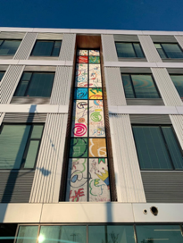
Since the high school designed YPAR to be year one of a four-year research sequence, there is room in the curriculum for students to continue to follow the topic and follow their questions. Importantly, students are learning the skills to do meaningful research about issues in their community that matter to them. Change often (almost always) happens more slowly than any of us would like, but by inviting 9th graders to commit to this kind of work as part of their lives in school, young people can learn how to make change happen. The opportunity to participate in work that invites young people to engage with adult community members and leaders and exercise their leadership with the project, allows young people to take control of their education and their world. YPAR helped to develop young people’s everyday literacies, but also, importantly, their critical consciousness and critical literacies.
We hope this case has offered new insights from an urban school-based setting, on the potential of YPAR to expand adolescents’ literacies, position students as researchers and community leaders, and revitalize what we typically see as high school research. YPAR offers youth a meaningful way to leverage and amplify youth voices for social change and develop their abilities as researchers, writers, and civic leaders. In short, students are learning, inspired by Gandhi, how to be the change they wish to see in the world. Findings have implications for educational practitioners and researchers who want to design more meaningful opportunities for all students in our schools.
In the short term, YPAR helps to enhance student engagement in their community. By integrating this work in school, it also has potential to increase students’ engagement in their own schooling. YPAR creates room in the school-sanctioned curriculum for youth to participate in social justice work that resonates with the youth movements that have erupted around #Black Lives Matter, climate change, gun violence, and more. Instead of seeing the young people who are advocating for change in those movements as an exception, this approach supports youth to see themselves as change agents and fosters capabilities for creating that change. Young people who are invited to engage YPAR have the chance to leave high school having experienced the concept of shared ownership for and responsibility to their community and that, on a fundamental level, changes in a community cannot come strictly from outside the community. Rather, community members must play a role in trying to understand the problem and develop ways to mitigate the problem.
References
Buckley-Marudas, M.F. (2018). Amplifying Voice, Facilitating Agency: Engaging Youth Participatory Action Research in an Urban Public High School. English Leadership Quarterly, 41(2).
Cammarota, J. (2016). Social Justice Education Project (SJEP): A case example of PAR in a high school classroom. In A. Valenzuela (Ed.), Growing critically conscious teachers: A social justice curriculum for educators of Latino/a youth (pp. 90–103). New York: Teachers College Press.
Cammarota J. & Fine M. (2008). (Eds.) Revolutionizing education: Youth participatory action research. New York: Routledge.
Diemer, M. A., Voight, A., & Mark, C. (2011). Youth development in traditional and transformational service-learning programs. In T. Stewart & N. Webster (Eds.), Problematizing service-learning: Critical reflections for development and action (pp. 155–174). Charlotte, NC: Information Age.
Duncan-Andrade, J & Morrell, E. (2008). The Art of Critical Pedagogy: Possibilities for Moving from theory to practice in urban schools. New York: Peter Lang.
Gupta, K. (2020). Youth Participatory Action Research: A Powerful Model for Youth Climate Literacy in PK–12 Classrooms. Ten Strands. Connecting Education, Environment, and Community. https://tenstrands.org/place-based-learning/youth-participatory-action- research-a-powerful-model-for-youth-climate-literacy-in-pk-12-classrooms/
Irizarry, J. G., & Brown, T. M. (2014). Humanizing research in dehumanizing spaces: The challenges and opportunities of conducting participatory action research with youth in schools. In D. Paris & M. T. Winn (Eds.), Humanizing research: Decolonizing qualitative inquiry with youth and communities (pp. 63–80). Los Angeles, CA: Sage.
Kornbluh, M., Ozer, E.J., Allen, C. D., & Kirshner, B. (2015). Youth Participatory Action Research as an Approach to Sociopolitical Development and the New Academic Standards: Considerations for Educators. Urban Review: Issues and Ideas in Public Education, 47(5), 868-892.
Martin, A. J., & Dowson, M. (2009). Interpersonal relationships, motivation, engagement, and achievement: Yields for theory, current issues, and educational practice. Review of Educational Research, 79 (1), 327–365. doi: doi.org10.3102/0034654308325583
Mirra, N., Garcia, A., & Morrell, E. (2016). Doing youth participatory action research: Transforming inquiry with researchers, educators, and students. New York: Routledge.
Mitchell, C. (1981). Typicality and the telling case. Ethnographic research: A guide to general conduct. London: Academic Press.
Ozer, E. J., Newlan, S., Douglas, L., & Hubbard, E. (2013). “Bounded” empowerment: Analyzing tensions in the practice of youth-led participatory research in urban public schools. American Journal of Community Psychology, 52(1-2), 13-26.
Ozer, E. J., & Wright, D. (2012). Beyond school spirit: The effects of youth‐led participatory action research in two urban high schools. Journal of Research on Adolescence, 22(2), 267-283.
Rubin, Beth C., Ayala, J. & M. Zaal. (2017). Authenticity, Aims and Authority: Navigating Youth Participatory Action Research in the Classroom. Curriculum Inquiry, 47(2), 175- 194.
Voight, A., & Velez, V. (2018). Youth Participatory Action Research in the High School Curriculum: Education Outcomes for Student Participants in a District-Wide Initiative. Journal of Research on Educational Effectiveness, 11(3), 433-451.

Author Bios
Mary Frances (Molly) Buckley-Marudas, Ph.D., is an associate professor in the Department of Teacher Education at Cleveland State University. Her research interests include youth-led research, adolescent literacies, digital literacy, and English education.

Charles Ellenbogen is a Language and Literacy teacher at Campus International High School in Cleveland, Ohio. His research interests include equity and justice in the classroom, English language arts instruction, digital literacies, and youth participatory action research.

Rachel Oscar is Director of Programming and Community Engagement at Campus District in Cleveland, Ohio. Her research interests include urban planning, and design and asset-based community development.

